Revit CAD Drawings of H₂O Degree Products Now Available for Download
3D CAD files of submetering system components now available for integration into Autodesk Revit and other Building Information Modeling Software Platforms
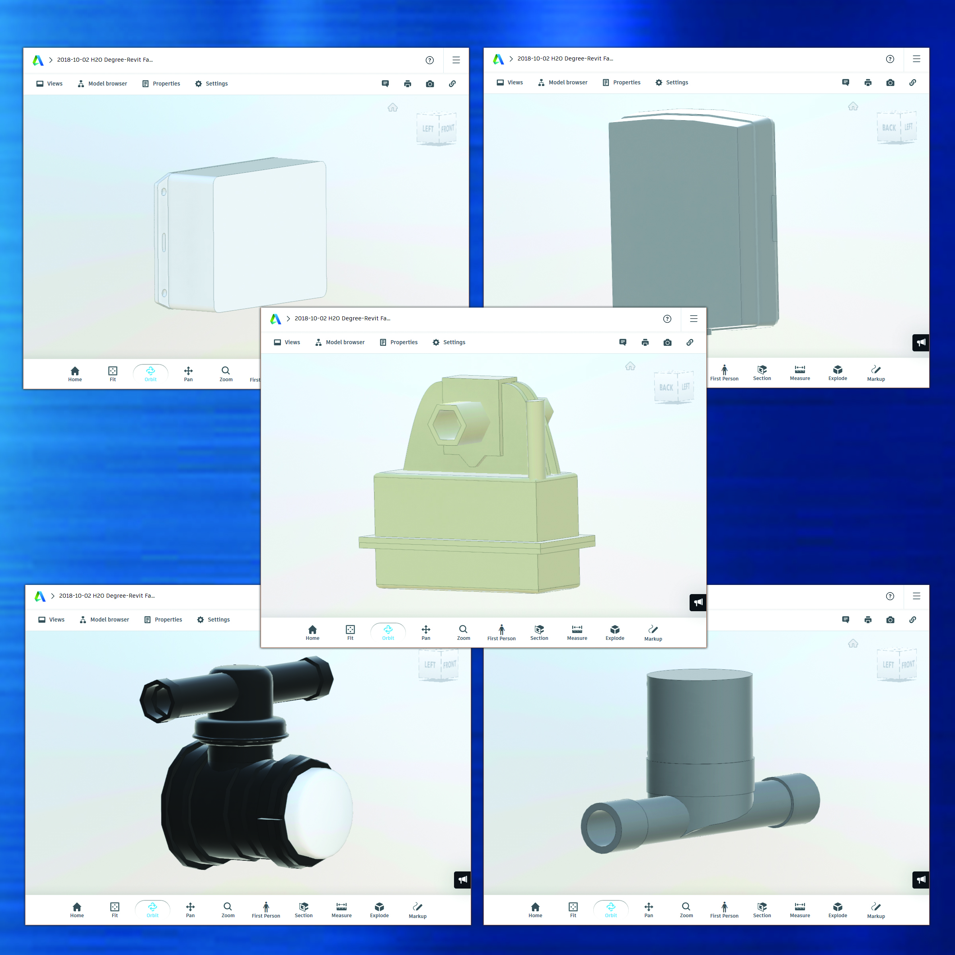
Bensalem, PA— November 6, 2018 — To support quick-and-easy building design and accurately represent installation layouts of the company’s popular water submetering systems, H₂O Degree now offers Revit® Family 3D CAD drawings of its products for importing and use in Building Information Modeling (BIM) software. Revit Family (.rfa) files are 3D, geometrically accurate models for integration into Autodesk Revit Project (.rvt) plumbing plans. Revit Family files can also be used with other BIM software
H₂O Degree is the leading manufacturer of advanced two-way wireless submetering systems used for tenant billing, leak detection & alarming, utility conservation and building automation system integration in multi-family facilities.
[Click on Image to download hi-res JPG]
Revit 3D models are available for these popular H₂O Degree submetering & leak detection products:
- M54120 Wireless Water Meter
- WM1100 Water Meter
- M54200 Wireless Mesh Transceiver
- M5423x and M54130 Wireless Pulse Counters
- IT1002 Gateway
“H2O Degree strives to provide our customers with quality, easy-to-use products from application & design to installation and use. These 3D CAD models provide engineers with a quick-and-easy way to integrate H2O Products into their building designs and layouts. H2O Degree products can be placed into a rendering of an actual room that includes other building equipment, so designers can see exactly how they will fit or interact with the rest of the environment,” said Don Millstein, President of H2O Degree.
To download a free copy of H2O Degree’s Revit CAD Drawings click here.
To view and download a copy of this press release click here.
To learn more about H₂O Degree’s submetering and leak detection system, please go to www.h2odegree.com. A catalog can be downloaded here.

About H₂O Degree
H₂O Degree manufactures a broad line of wireless radio-based submetering and leak detection systems that measure individual apartment or condo use of water, domestic hot water energy, boiler and chiller energy, electricity, gas and BTUs. The systems are ideal for tenant billing, leak detection reporting down to the toilet level and energy analytics. The company also offers Green Thermostats, which track energy use and apartment temperature while allowing tenants and property owners to set temperature set-points and schedules, adjust set-back temperatures when tenants are away or asleep, report HVAC maintenance issues, and provide control for vacant utility cost. For more information, please go to: www.h2odegree.com.

Contacts:

Don Millstein, President
H₂O Degree
215-788-8485 x200
donmillstein@h2odegree.com

Greg Evans, Account Executive
WelComm, Inc.
858-633-1911
greg@welcomm.com

