Heather Caldwell Joins the H₂O Degree Management Team
Seasoned customer service veteran adds her special talents to support H₂O’s growth
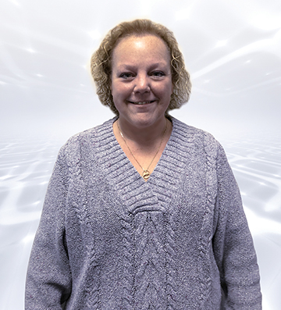
Bensalem, PA— March 28, 2019 — H₂O Degree, manufacturer of advanced two-way wireless submetering systems for tenant billing, leak detection, utility conservation and building automation system integration in multi-family facilities, announces the addition of Heather Caldwell to its management team.
Heather has an extensive background in submetering, having served for over 30-years as customer service/inside sales manager at E-Mon Corporation, under the leadership of Don Millstein who is now President of H₂O Degree. Ms. Caldwell will be managing inside sales and customer service and supporting H₂O’s extensive and expanding network of reps and distributors. She will also provide application support to end-users.
President of H₂O Degree, Don Millstein, said: “After working together for so many years at E-Mon, it is great to be reunited with Heather Caldwell as part of our management team here at H₂O Degree. She brings a special level of energy and customer insight into her work that infects everyone she deals with.”
About H₂O Degree
H₂O Degree manufactures a broad line of wireless, radio-based submetering and leak detection & alarming systems that measure individual apartment or condo use of water, domestic hot water energy, boiler and chiller energy, electricity, gas and BTUs. The company also offers Green Thermostats which track energy use and apartment temperature while allowing tenants and property owners to set temperature set-points and schedules, adjust set-back temperatures when tenants are away or asleep and report HVAC maintenance issues. For more information, please go to: www.h2odegree.com. Orders can be sent to orders@h2odegree.com and request for quotes can be sent to quotes@h2odegree.com

Contacts

Don Millstein, President
H₂O Degree
215-788-8485 x200
donmillstein@h2odegree.com

Greg Evans, Acct. Exec.
WelComm, Inc.
858-633-1911
greg@welcomm.com

