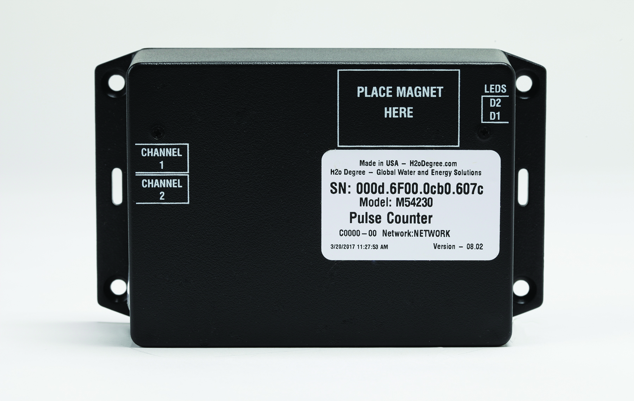
New H₂O Degree 10-Year Battery-Operated Wireless Pulse Counters Facilitate Collection of Utility Consumption Data
Offered with or without LCD display, units easily connect to new or retrofit submeters (water, electricity, gas and BTUs)

Bensalem, PA— May 16, 2017 — H₂O Degree, manufacturer of advanced two-way wireless mesh submetering systems for tenant billing, leak detection, utility conservation and building automation system integration in multi-family facilities, announces the release of the new 10-year-life, battery-powered, two-channel wireless pulse counters. The units monitor and record dry-contact pulses from submeters and utility meters to record consumption utilizing a 32-bit, cumulative pulse counter registered for each of the two channels. The data is then reported via a battery-powered wireless radio compatible with H₂O Degree’s secure wireless 2.4 GHz mesh network.

The compact (5.4in H x 3.3in W x 1.7in D) H₂O Degree pulse counters are easy to install and reliable in operation. Commissioning is easy. The installer initiates a radio transmission and receives a LED indication and confirms a successful radio transmission. The units have a warrantied 10-year battery life and continue counting pulses – even if the radio is unable to transmit data. Non-volatile memory maintains the last reading if transmission is interrupted due to power failure.

The battery-powered wireless pulse counter is available with a LCD display (model M54232) or without a display (model M54230), and both models support water, gas and BTU meters. The H₂O Degree pulse counters comply with U.S. and European regulatory approvals and come with a ten-year warranty. H₂O Degree continues to offer the M54130 line-powered 4-channel pulse counter that also functions as a repeater in the H₂O Degree wireless mesh network.

President of H₂O Degree, Don Millstein, said: “Our new two-channel wireless pulse counter makes it easy for meter reading service providers/RBCs and property managers to remotely collect the utility data they need for their new or existing installations. We’re pleased to add this feature-rich pulse counter to complement our portfolio of advanced submetering systems.”

To learn how H₂O Degree’s submetering and leak detection system results in significant savings, please go to www.h2odegree.com.

About H₂O Degree
H₂O Degree manufactures a broad line of wireless mesh, radio-based submetering and leak detection systems that measure individual apartment or condo use of water, domestic hot water energy, boiler and chiller energy, electricity, gas and BTUs. The systems are ideal for tenant billing, leak detection reporting down to the toilet level and energy analytics. The company also offers Green Thermostats, which track energy use and apartment temperature while allowing tenants and property owners to set temperature set-points and schedules, adjust set-back temperatures when tenants are away or asleep, report HVAC maintenance issues, and provide control for vacant utility cost. For more information, please go to: www.h2odegree.com.

Contacts:

Don Millstein, President
H₂O Degree
215-788-8485 x200
donmillstein@h2odegree.com

Marsha Ryan, Account Executive
WelComm, Inc.
858-633-1930
marsha@welcomm.com

