H₂O Degree’s New Catalog Features Advanced Utility Submetering and Leak Detection and Environmental Control Solutions for Multi-Family Facilities
Comprehensive resource provides product information, application details and case study examples; expanded product offering includes new LoRaWAN enabled submetering systems
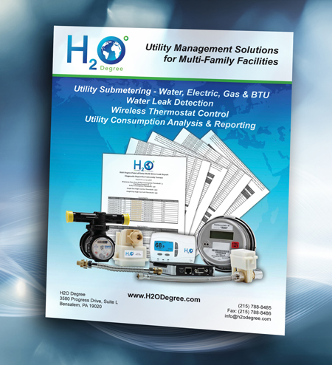
Bensalem, PA— June 27, 2019 — H₂O Degree, the leading supplier of utility management products for multi-family facilities for over a decade, announces publication of an expanded, comprehensive submetering guide titled “Utility Management Solutions for Multi-Family Facilities.” Now available for download on the company’s website, the publication details the benefits of using H₂O Degree’s advanced submetering systems (water, electric, gas, BTUs), leak detection, thermostat control (including a new EnOcean radiator control interface), and reporting solutions, all which support increased building efficiency, lowered utility costs, energy-saving Green Building initiatives and LEED certification programs. It also provides extensive product application information, technical specifications, engineering data and practical information about reporting and billing.
(Click here or on image to download high-res JPEG)
The foundation of the H₂O Degree system is the company’s two-way wireless communication infrastructure, now including adaptation of the latest wide-area network technology (LoRaWAN) as well as H₂O’s proprietary mesh network. The new catalog presents case studies about residential buildings that have already realized dramatic utility cost savings using the comprehensive systems approach, such as cutting their water usage in half.
“H₂O Degree’s new catalog offers a wealth of valuable information for incorporating H₂O Degree’s advanced water and energy-efficiency solutions to save money at multi-family buildings,” said H₂O Degree’s president, Don Millstein. “Property owners and managers can use our system’s smart water meters, thermostat control capabilities and daily leak-detection reporting to pinpoint and fix water leaks and to accurately bill tenants for their individual usage. This enables them to reduce and recoup utility costs – the single largest controllable expenditure in multi-family communities.”
To learn how H₂O Degree’s submetering and leak detection system results in significant savings, please visit www.h2odegree.com. To download a copy of the new H2O Degree catalog click here.

About H₂O Degree
H₂O Degree manufactures a broad line of wireless, radio-based submetering and leak detection systems that measure individual apartment or condo use of water, domestic hot water energy, boiler and chiller energy, electricity, gas and BTUs. The company also offers Green Thermostats, which track energy use and apartment temperature while allowing tenants and property owners to set temperature set-points and schedules, adjust set-back temperatures when tenants are away or asleep, report HVAC maintenance issues, and provide control for vacant utility cost. For more information, please visit www.h2odegree.com

Editorial Contact
Don Millstein, President
H₂O Degree
215-788-8485 x200
donmillstein@h2odegree.com

Agency Contact:
Greg Evans, P.E., Account Executive
WelComm, Inc.
858.633.1911
greg@welcomm.com

