H₂O Degree’s Industry-First LoRaWAN-Based Pulse Counter Enables Longer-Distance, Faster Utility Meter Data Collection – No Repeater Network Needed
New L54230 LoRaWAN pulse counter offers performance/cost benefits for tenant water and energy utility billing in multi-family buildings compared with products using closed-protocol networks

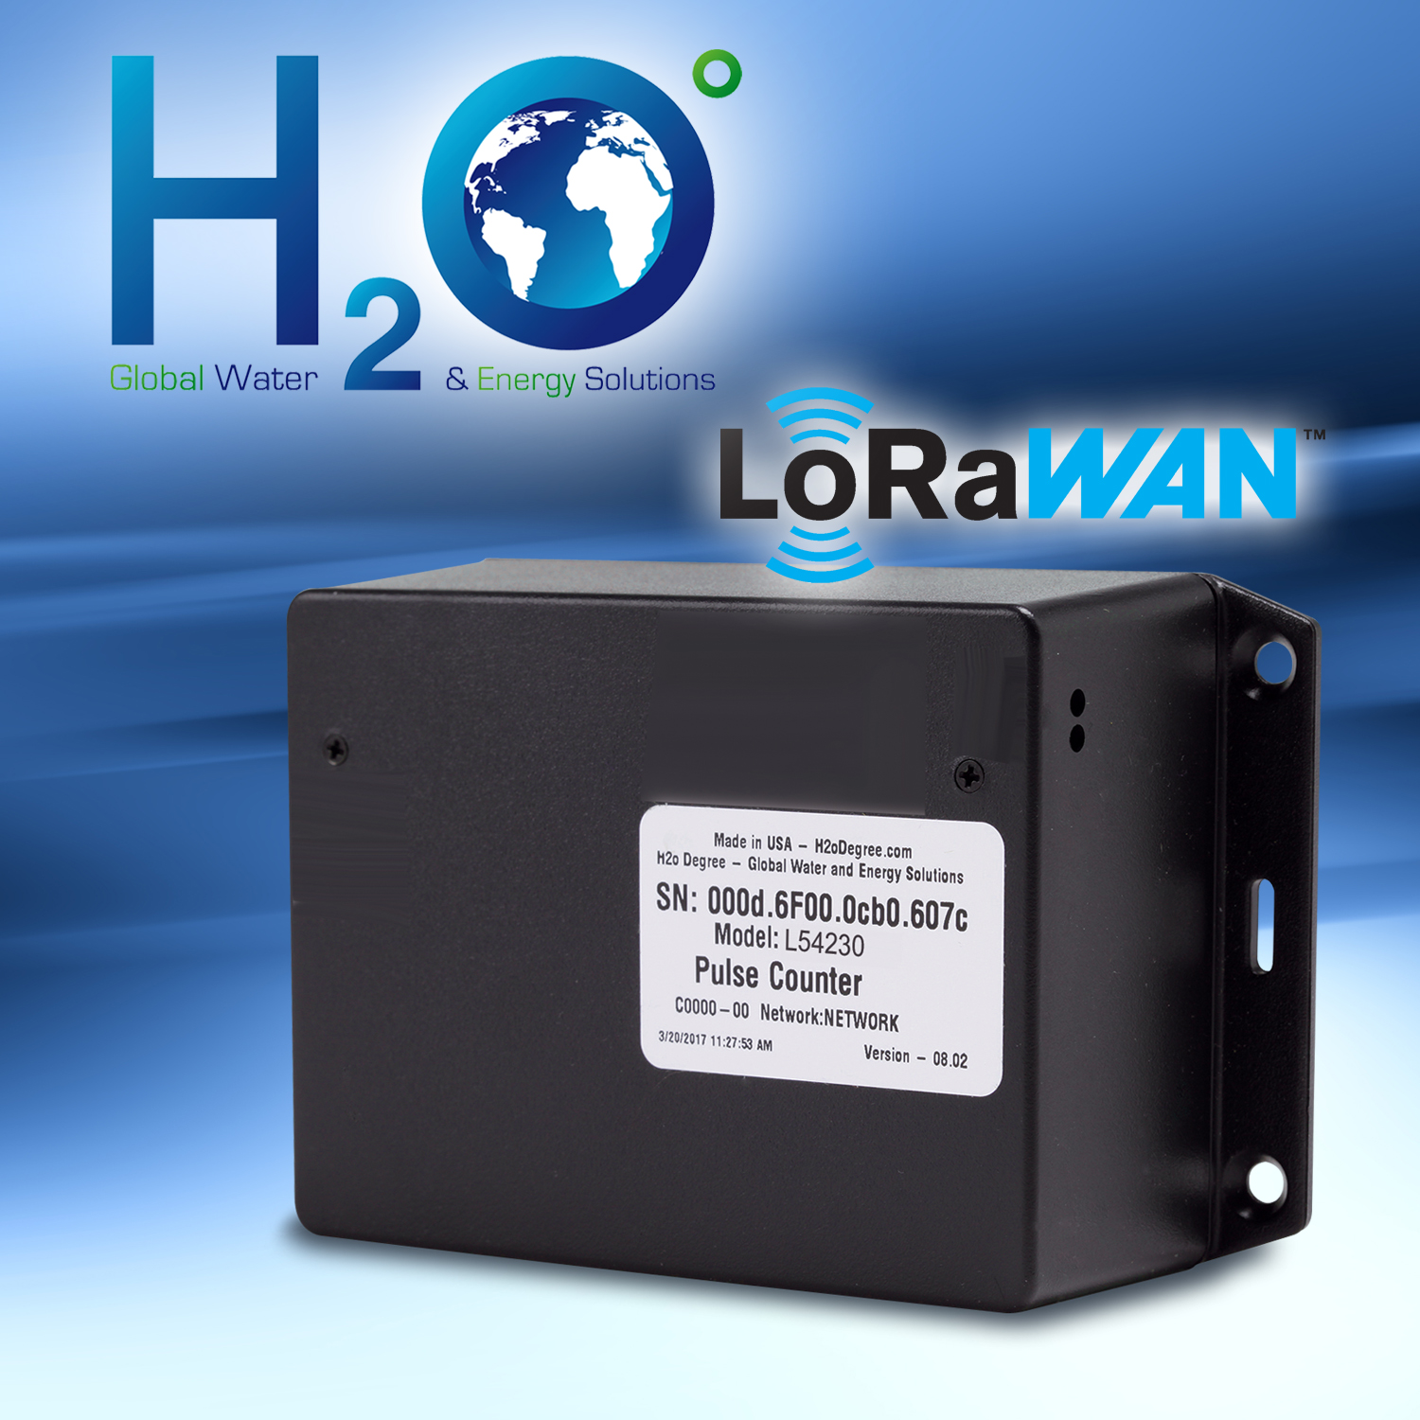
(Ctl+Click image to download high-res JPEG)
Bensalem, PA— June 19, 2018 — Marking an important development in metering technology for tenant utility billing, H₂O Degree introduces the industry’s first LoRaWAN-based meter pulse counter designed to operate with most pulse-output water and gas meters. H₂O Degree is the leading manufacturer of advanced two-way wireless mesh submetering systems used for tenant billing, leak detection, utility conservation and building automation system integration in multi-family facilities. The company’s new L54230 pulse counter is unique in its ability to communicate via the open-protocol LoRaWAN™ (long-range wide area network) platform to remotely monitor and record utility submetering data. Unlike typical units that connect over proprietary protocols, the pulse counter’s cloud-based LoRaWAN platform does not require a dedicated PC or software – or a repeater network. The new H₂O Degree LoRaWAN-based pulse counter improves data-collection speed, accuracy and communication distance, all while simplifying and reducing the cost of submetering installations.

Each L54230 LoRaWAN two-channel wireless pulse counter can monitor and record dry-contact pulses from two separate (new or retrofit) gas or water utility meters. Water meters that the pulse counter can connect to include: Badger, Elster (AMCO), Master Meter, Norgas, Neptune and SENSUS. Gas meters include: Dattus, Itron Metris and Norgas. The pulse counter’s Class A secure wireless 915 MHz interface offers line-of sight, bi-directional communications of over six miles compared to the three-mile range of conventional products. In garden-style multi-family facilities, L54230 units can operate within a 1,000-foot radius from the gateway, covering a 70-plus-acre property. High-rise buildings have a 25-story radius from the gateway, ultimately covering a 50-story building with no repeaters.

“Our one-of-a-kind LoRaWAN meter pulse counter offers building owners and managers significant data-collection and installation cost advantages when tracking tenant metering data compared to using conventional products,” said President of H₂O Degree, Don Millstein. “Not only is communication increased to twice the distance of the industry standard, it eliminates the need for 10 to 20 repeaters.” He continued: “And because it’s based on the increasingly popular open protocol, our L54230 pulse counter will be able to integrate with existing and future LoRaWAN-enabled metering products used for on the floor flood detection and remote water shut-off.”

As with H₂O Degree’s existing line of wireless pulse counters, the LoRaWAN pulse counter is compact (5.36in H x 3.33in W x 1.73in D) and easy to install. Commissioning is very user-friendly: the installer simply initiates a radio transmission, receives LED indication and confirms success. The product is backed by H₂O Degree’s 10-year battery-life guarantee, which is double the industry norm, and is backed by a five-year warranty.

A datasheet of the L54230 LoRaWAN two-channel wireless pulse counter can be found here.

To learn more about H₂O Degree’s submetering and leak detection system, please go to www.h2odegree.com. A catalog can be downloaded here.

About H₂O Degree
H₂O Degree manufactures a broad line of wireless mesh, radio-based submetering and leak detection systems that measure individual apartment or condo use of water, domestic hot water energy, boiler and chiller energy, electricity, gas and BTUs. The systems are ideal for tenant billing, leak detection reporting down to the toilet level and energy analytics. The company also offers Green Thermostats, which track energy use and apartment temperature while allowing tenants and property owners to set temperature set-points and schedules, adjust set-back temperatures when tenants are away or asleep, report HVAC maintenance issues, and provide control for vacant utility cost. For more information, please go to: www.h2odegree.com.

Contacts:

Don Millstein, President
H₂O Degree
215-788-8485 x200
donmillstein@h2odegree.com

Marsha Ryan, Account Executive
WelComm, Inc.
858-633-1930
marsha@welcomm.com

