H₂O Degree Adds Water Meters to Its LoRaWAN Wireless Submetering Network
WM-2100 Series, ¾-inch single-jet, 22 gpm water meters and WM-2200 Series 1-inch and 1 ½-inch multi-jet
meters designed for higher flowrates are offered in hot water and cold water versions; LoRaWAN-enabled
meters offer cost-effective means of gathering water consumption data.
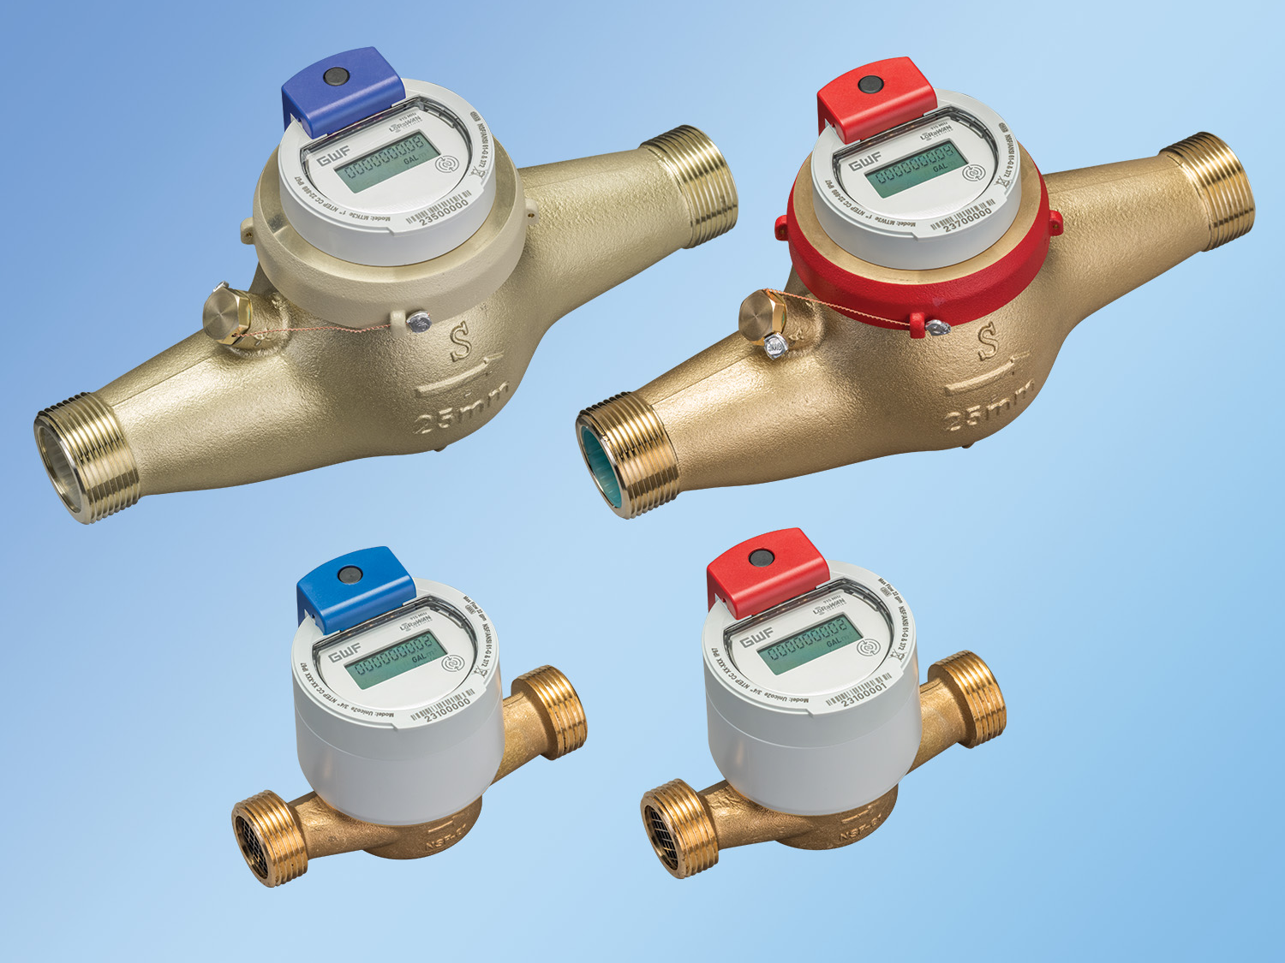
Bensalem, PA— May 2, 2024— H₂O Degree – manufacturer of advanced two-way wireless submetering systems for tenant billing, leak detection, utility conservation and building automation system integration – announces two new series of LoRa-enabled water meters available in versions for both hot and cold water lines. The WM-2100 Series ¾” single-jet units typically for individual multifamily units, handle 22 gpm, max and the WM-2200 Series, higher volume, multi-jet meters are offered in 1” and 1 ½“ versions for maximum continuous flow rates of 44 gpm and 70 gpm, respectively. All are equipped with electronic encoded registers to record volume. The units’ dry-dial meter with magnetic coupling assures reliable measurements that meet AWWA C-708 standards for accuracy. WM-2100 and WM-2200 models feature simple NFC tap-and-go commissioning, plug-and-play LoRaWAN activation and 10 years of battery life. All meters are constructed of robust utility-grade, sustainable materials.
Click on photo to download hi-res JPG
As LoRa-enabled devices, the WM-2100 and WM-2200 hot and cold water meters communicate over the H₂O Degree LoRaWAN open protocol wireless network. This enables long-range (10-mile, line-of-site) transmission of the meters’ monitoring data – resulting in information that is accessible over H₂O Degree’s online dashboard by property managers and/or third-party billing companies.
“As an original adopter of using the LoRaWAN protocol network for submetering, H₂O Degree has seamlessly integrated more than 50,000 LoRa-enabled devices in 400 properties over the past four years,” said Don Millstein, President of H₂O Degree. “Our new LoRa-enabled, water meters offer property owners yet another easy, cost-effective way to gather precise metering data for accurate, simplified utility billing.”
WM-2100 and WM-2200 series water meters are certified for the State of California, NTEP (CC 19-019A2) approved, NSF/ANSI 61-G and 372 certified and marked. The meters are New York certification (No. 10766) Massachusetts certified (No. P-2024-466) and are LoRa Alliance (1.0.4 spec) certified.
About H₂O Degree
H₂O Degree manufactures a broad line of wireless radio-based submetering and water leak and flood detection systems that measure individual apartment or condo water use, domestic hot water energy, boiler and chiller energy, electricity, gas, and BTUs. The systems are ideal for tenant billing and leak detection reporting down to the toilet level, and energy analytics. H₂O Degree’s wireless Green Thermostat control solution tracks energy use and apartment temperature while allowing tenants and property owners to set temperature set-points and schedules, adjust set-back temperatures when tenants are away or asleep, report HVAC maintenance issues, and control for vacant utility cost. In 2000, the company was among the first to deploy the long-range wireless LoRaWAN network in multi-tenant submetering installations. H₂O Degree also offers LoRa-enabled window and door sensors, as well as wireless water-detection floor sensors and automatic shut-off valves that help property owners meet flood insurance requirements. More at: h2odegree.com.

Contacts
Suzy Abbott, Marketing Manager
H₂O Degree
215-788-8485
sabbott@h2odegree.com

Greg Evans, P.E., CEO
WelComm, Inc.
858-633-1911
greg@welcomm.com

